* **Inventory Encoding**

1. **Click Menu**

Menu

1. **Click Transactions**

Transaction

1. **Click Inventory Encoding**

Inventory Encoding

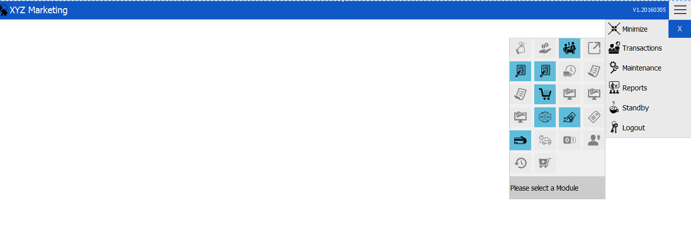

* **New Inventory Encoding Transaction**

Location

Branch

Counted By

Update

Add

Checked By

Sheet Number

Delete

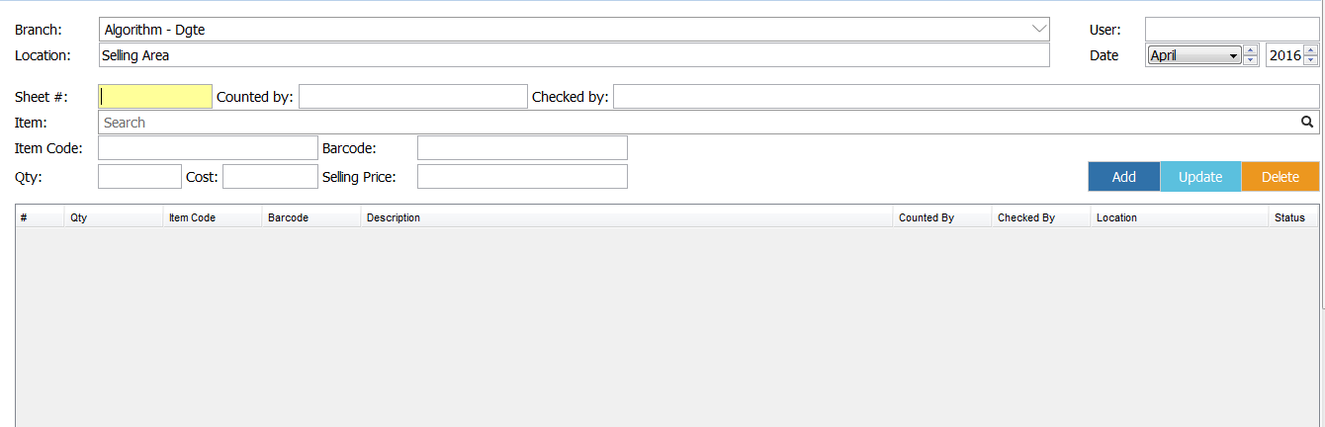

1. Choose branch

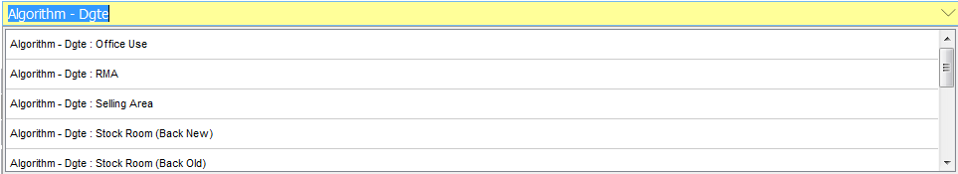

Note: **You can press enter or just click the search bar to show branch lists.**

1. Location



**Your Location tab is where your chosen branch will be placed.**

1. Input Sheet Number



1. Input Counted By



1. Input Checked By



1. Search Item Bar



**Note: You can also press enter to view all customers list.**

1. Input quantity



1. ADD

**After searching an item, just press Enter or click ADD button**





**This message box will show if you successfully added an item.**

**Note: Upon adding an item, its status is POSTED which means it needs to be finalized to reflect it on the INVENTORY SHEET.**

1. UPDATE

**If you want to update an item, just click the item on the display area and then click the “UPDATE” button .**





**This message box will show if you successfully updated the item.**

1. DELETE

**If you want to delete an item, just click an item to be deleted on the display area and then click the “DELETE” button.**



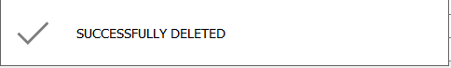

**This message box will be shown once you successfully deleted the item.**

* **Finalizing Inventory Encoding**

1. **Click Menu**
2. **Click Transaction**
3. **Click Inventory – Encoding Finalize**

Transaction

Menu

Inventory Encoding - Finalize



Search

User

Sheet Number

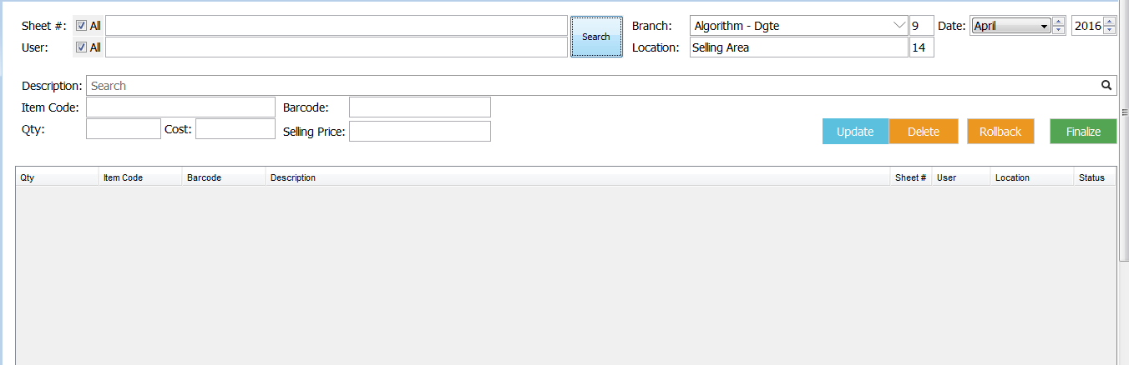

Finalize

Display Area

1. Select Sheet Number



**Note: If you want to select all, you can check the checkbox.**

2. Select user



**Note: If you want to select all, you can check the checkbox.**

3. Click Search



4. Click the item on the display area and then click Finalize button.

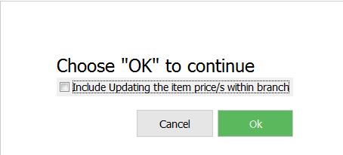

**This message will be shown upon clicking the Finalize button. Just click OK.**

5. Item Status



**If your item status is OK, it means it is already finalized.**

**Note: Finalized item could no longer be deleted.**